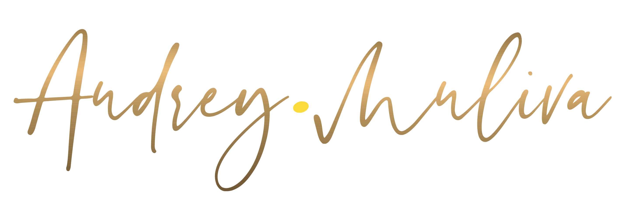
LONG BIO
How are your teams responding to all the digital tools you’ve invested in?
If the answer is “not as well as we hoped,” time to act .
In today’s hyperconnected workplace, technology promises productivity but often delivers burnout. Audrey is the voice leaders turn to when they need clarity, connection, and culture in the digital age.
With 20 years in digital spaces, Audrey brings deep expertise and lived insight to every stage. Her career spans corporate management in global food manufacturing groups like General Mills and Campbell’s, as well as human-centered work in real estate, where she applied herself to mitigating the rental crisis with empathy and action. She’s a professionally trained keynote speaker, certified speaker coach, and accredited Digital Wellness Educator through the renowned Digital Wellness Institute. Her mantra, “Better Connected than Depleted,” is more than a message , it’s a movement. She’s also co-authored two Amazon bestselling books in collaboration with online connections , a testament to the power of digital relationships and shared purpose.
Audrey’s AHA moment came when she realised that no amount of tech training would shift behavior unless leaders began to see digital tools through a more human lens embracing it as an ally.
Her keynotes spark this shift, guiding teams toward intentional engagement, resilience, and human-centered evolution in the digital era.
Known for her dynamic presence, Audrey brings the best of her humanness to every stage. She leads with emotional depth and mental clarity, keeping audiences engaged, challenged, and inspired to evolve through digital technology.
SHORT BIO
We’re surrounded by digital tools but are they helping us thrive, or quietly draining our energy?
Audrey is a dynamic keynote speaker and certified Digital Wellness Educator who blends emotional intelligence, lived experience, and inspiring frameworks to challenge how we think, feel, and behave around technology. Her career spans corporate management in global food manufacturing groups like General Mills and Campbell’s, and human-centered work in real estate focused on mitigating the rental crisis. Her mantra, “Better Connected than Depleted,” sets the tone for a talk that’s deeply human and intentionally disruptive.
Audrey brings the best of her humanness to every interaction , guiding audiences to see digital not as a threat, but as a catalyst for evolving our humanity. Her ultimate goal: to help people embrace technology with emotional intelligence at the core creating healthier, more connected ways of working, leading, and living.

