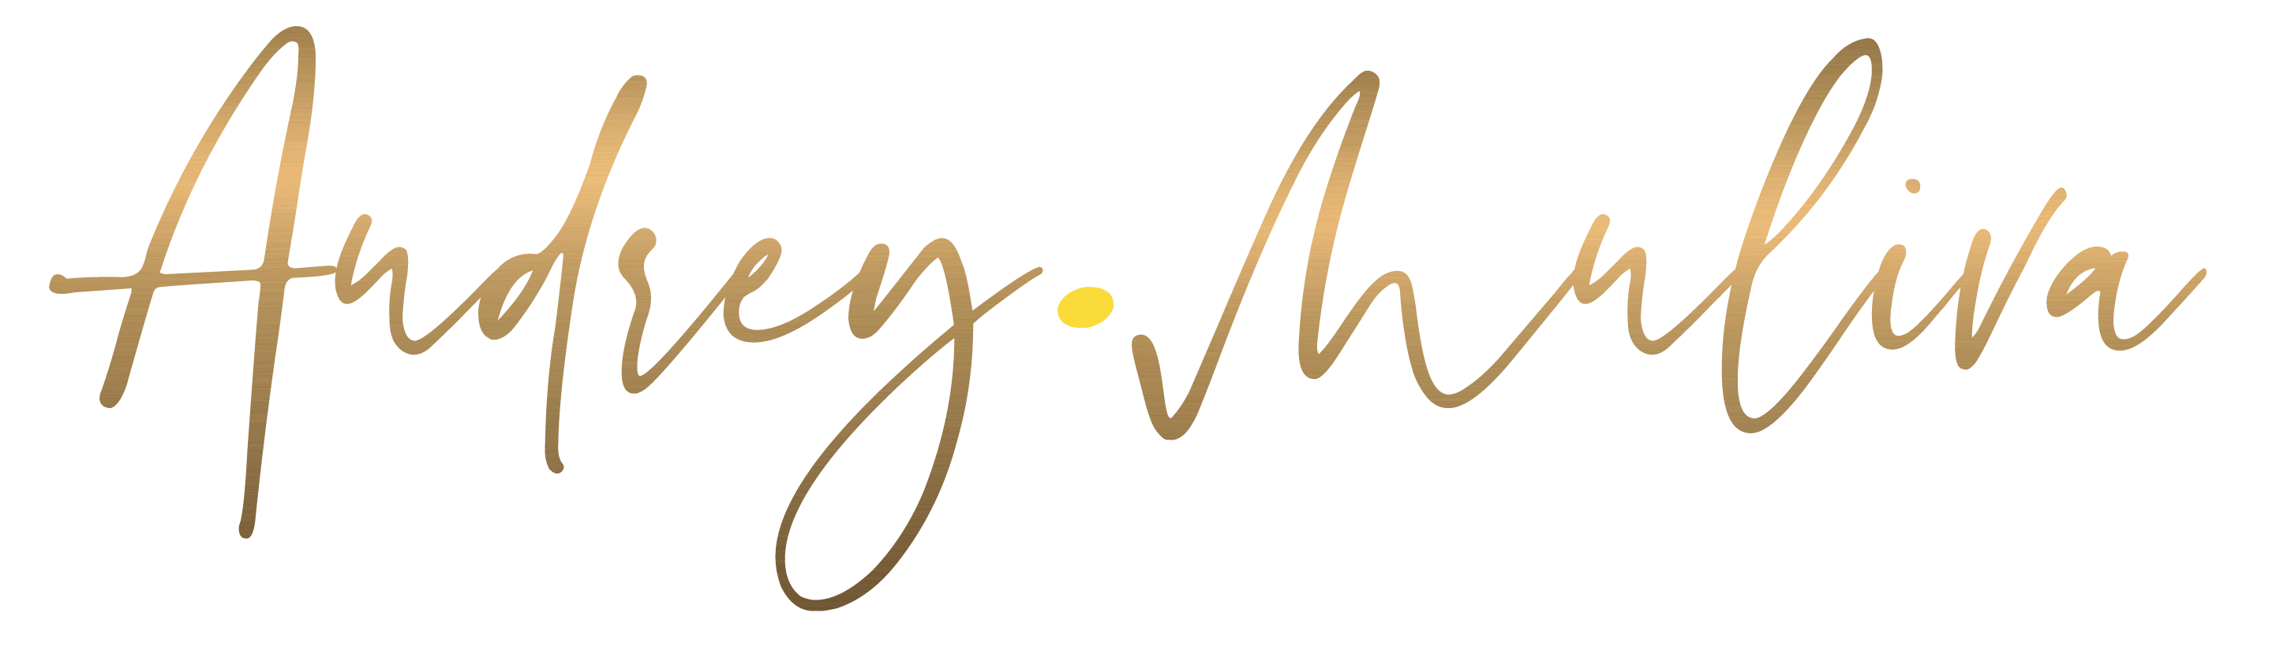
Back in 2018, when “digital wellbeing” was still a mystery to most, Audrey was already speaking about it , on stage and through her podcast , planting seeds for a healthier relationship with technology long before it became a buzzword. Her journey spans corporate management in global manufacturing groups like General Mills and Campbell’s, and more recently, human-centered work in real estate, where she tackled the rental crisis with empathy and action. Today, she’s on a mission to help us find something even more elusive: digital clarity in a hyperconnected world.
Audrey is originally from France , but don’t expect clichés. No beret, no baguette, and whatever you do, don’t give her coffee before she speaks… unless you want the talk fast-forwarded to warp speed. What she will bring is a blend of emotional intelligence, lived experience, and inspiring frameworks that challenge how we think, feel, and behave around technology.
Her mantra, “Better Connected than Depleted,” is just the beginning , she’s bringing a whole set of digital mantras designed to spark reflection, laughter, and real change.
Her vision? To make the online world a healthier place for all of us. Utopian? Maybe. But if anyone can turn a Wi-Fi signal into a wellbeing revolution, it’s her.
Get ready to laugh, reflect, and rethink your relationship with tech .
Because this talk isn’t just about digital transformation. It’s about our healthiest social evolution.
Please welcome Audrey...

